

Robotic Sorting of Engine Blades



Principal Investigator: Dr. Yahya Zweiri  Date: December 2021 | Approved by Director of ARIC:  Date:
Approved by: ARIC Senior Management Board
Date of meeting:

PROJECT DEFINETION
The sorting of engine blades according to their mass is an important step in the assembly of aeroplane engines. This task is currently being conducted manually in Sanad, where a technician needs to weigh and label each blade individually; and then sort them accordingly. This manual operation is time consuming, and prone to human error. As such, the automation of this task is highly desirable. The robotics team at Khalifa University has been developing autonomous robotic manufacturing capabilities, including solutions for pick and place and sorting applications. This document forms a Statement of work for the collaboration between Sanad and Khalifa University to develop and deploy a robotic sorting system for engine blades.

For a successful automated sorting system, the robot must possess several capabilities of perception and manipulation. First, the robot must be able to localize each blade in 3D space through machine vision and LiDAR. In some case, the robot must also be capable of identifying the serial number engraved on each blade. The robot must then be able to grip/grasp all the different blade variants securely. This would require the design and fabrication of an end-effector with an embedded vacuum gripping ability. The robot must then measure the mass of the blades; which can be achieved either through an onboard Force/Torque sensor or an offboard scale. Finally, a software that keeps track of the location and mass of all blades and then sort them accordingly needs to be developed.
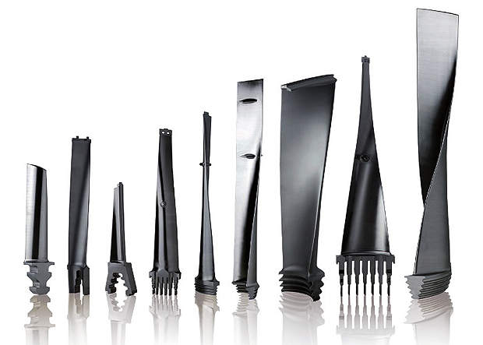
Figure 1. Different design, shapes, and sizes of turbine engine blades

Following the above requirements, the robotics team at Khalifa University will develop this robotic sorting system and customize to the needs of Sanad. The remainder of this document specifies the deliverables, required resource, budget, and timeline for this project.

OBJECTIVES
- The development of a robotic system capable of sorting blades according to their mass, and clustering blades of similar mass accordingly. Development includes:
  - The development of an end-effector capable of gripping the different types and sizes of blades. Several gripping mechanisms will be investigated including vacuum grippers.
  - The ability to weigh each blade with 0.1 gram precision. Different methods will be investigated including an external weighing scale and the use for a Force/Torque sensor.
  - The software to track and sort blades according to their mass.
  - The ability to read the serial numbers engraved on each blade. Conventional vision and laser-based approaches will be studied for this task.
- The training of national Khalifa University students on robotic manufacturing technologies, including the mathematical fundamentals, robotic perception, mechanical design and the operation of robots in the industry.

APPROACH
The main components of the robotic sorting system are: perception, sensing, manipulation, and a mission management software. A summary of the objectives and approach for each of these subsystems is proved below:

Perception
- Objectives:
- The localization of each blade in 3D
- The identification of the serial number engraved on each blade.
- Approach
- Depth camera (intel d435)
- Laser Profilers
- Steady State LiDAR
- Neuromorphic vision

Sensing
- Objectives:
- The weighing of each blade with 0.1 g accuracy
- Approach
- An offboard weighing scale
- An onboard Force/Torque sensor

Manipulation
- Objectives:
- Adjust the placement of the blades following the perception and sensing stages.
- Approach
- A collaborative serial robot manipulator
- A customized end-effector with vacuum gripper.

Mission Management
- Objectives:
- Track the progress and manage the different stages of the sorting process with safety and efficiency considerations.
- Approach
- A custom-built software with ROS interface.

DELIVERABLES
- A fully-functional prototype of a robotic sorting system capable of sorting and clustering multiple blades with 0.1 gram precision.
- Full reporting and documentation of the developed system inducing hardware and software.
- A journal paper that targets the use of new technologies to increase the speed, efficiency and reliability of the robotic sorting process.

HUMAN RESOURCES
Resource | Allocation
Dr. Yahya Zweiri (PI) | 10%
1 Research Assistant | 100%
Student Involvement (Undergraduate) | 3 to 4 national students

GANTT CHART
Work Package | Month
 | 1 | 2 | 3 | 4 | 5 | 6 | 7 | 8 | 9 | 10 | 11 | 12
Literature Review & Investigation
Procurement of required equipment
The design and fabrication of blade gripping end-effector
Prototype A: Sorting using an external scale
The development of a perception method to recognize serial number
Weighing using F/T sensing
Prototype B: Sorting with onboard weighing
Tests and evaluation
Upgrade of prototype to industrial standard
Project Closure and recommendations

- The Gantt Chart is subject to the date of initiation of the project.

ESTIMATED BUDGET inc all costs such as manpower, opex and capex
CAPEX | 350,000 AED
OPEX | 100,000 AED
Manpower | Equivalent to 1 Research Associate
- CAPEX cost includes the cost of all equipment listed under section 8 of this report, and can be altered according to the final selection of equipment to be purchased.

EQUIPMENT REQUIREMENTS
- A collaborative robotic manipulator (UR10e)
- A weighing scale with a precision of 0.1 grams and a digital interface
- A Force/Torque sensor with a precision of 0.001 N and mass of no more than 5 Kg.
- High resolution cameras
- Neuromorphic cameras
- A laser profiler
- 3D printer for rapid prototyping
- Vacuum grippers from Festo
- An intel LiDAR Camera L515

PROJECT SPECIFIC SMART KPIs
- One journal paper in Q1 journals.
- Fully Functional prototype (hardware & software) for the robotic sorting process
- The training of 3-4 undergraduate students.

PROGRESS REPORTING

- Progress reports - Monthly progress reports will be prepared by the PI and submitted to the project lead per email at the end of each month.
- Interim technical report after 6 months. Final technical report at the end of the project.
- Full documentation of robot hardware & software to be provided at the end of the project.

